**N.M.A.M. INSTITUTE OF TECHNOLOGY**

**DEPARTMENT OF INFORMATION SCIENCE AND ENGINEERING**

**A MINI ON PROJECT REPORT ON MUSIC PLAYER**

SUBMITTED BY: -

SHIVANI.S SAMHITHA.K

4NM17IS096 4NM17CV088

SUBMITTED TO:-

Ms.NIKITHA SAURAB

ASST.PROFESSOR

INTRODUCTION

* PYTHON

Python is a general-purpose, dynamic, object-oriented programming language. The design purpose of the Python language emphasizes programmer productivity and code readability. Python was initially developed by Guido van Rossum. Python is a programming language that lets you work quickly and integrate systems more efficiently. It was mainly developed for emphasis on code readability, and its syntax allows programmers to express concepts in fewer lines of code.

* Tkinter

The Tkinter module (“Tk interface”) is the standard Python interface to the Tk GUI toolkit from Scripts. which is the default GUI package that comes bundled with Python.tkinter provides us with a variety of common GUI elements which we can use to build our interface – such as buttons, menus and various kinds of entry fields and display areas. We call these elements widgets.

* MUSIC PLAYER USING GUI IN PYTHON

The Graphical User Interface (GUI) is of a music application consisting the basic features of music player like play, pause, stop, rewind and volume adjustment. The working is very simple just like a usual music player the song can be added directly by using the button add or by option called open from drop down menu box. The songs added will be added to play list box and any undesired song can be deleted using the delete button present below it.

The interface consists of 6 buttons with functions of addition of a song to the player list(add), deletion of the song from player list(delete), play, pause, stop for playing, pausing and stopping the song when desired respectively. These three buttons are put into a frame.

The interface consists a menu bar with option file and help and a drop down option from file which has the option of open, new playlist and exit. The help option displays a message box which shows the information.

The open option browses the file and a .mp3 file can be chosen and the exit option to exit from the application.

A scale for monitoring the volume is present which adjusts the volume of the song being played.

SOFTWARE REQUIREMENT SPECIFICATIONS

HARDWARE REQUIREMENTS

1.Processor-Intel® Core™ i3-5005U CPU @ 2.00GHz

2.RAM Size-4.00GB

3.Display -1366x768 Resolution monitor

4.Network interface card

SOFTWARE REQUIREMENTS

1.Operating System-Windows 10

2.Programming Language –Python-IDLE-Version-3.7

3.System Type-64-bit Operating System

SCREEN SHOTS

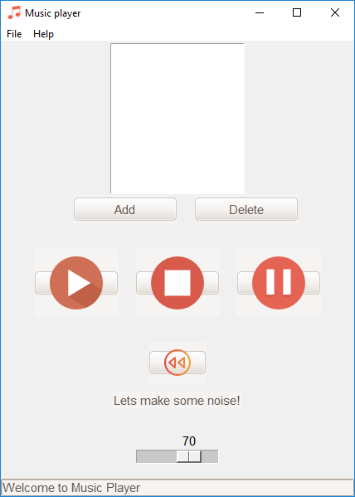

1.the first page or welcome page appearing once the program in runned.

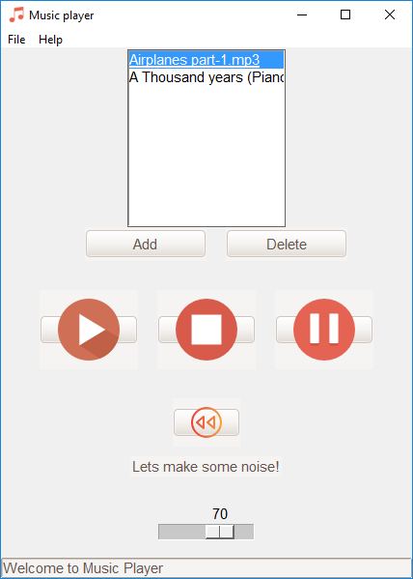

2.The songs are added into the playlist using the add and open option fronm the menu bar.

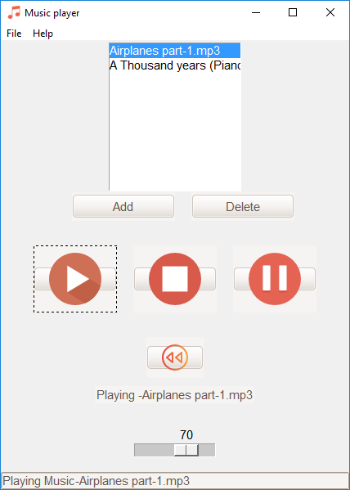

3.The first song in the playlist is being played

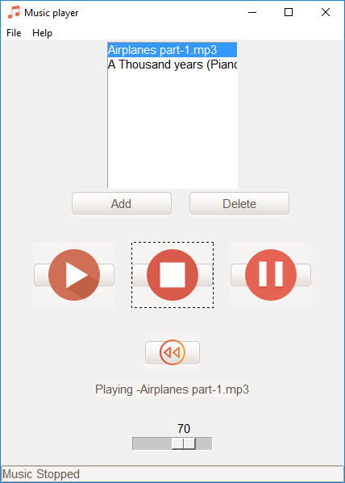

4. Music being stopped

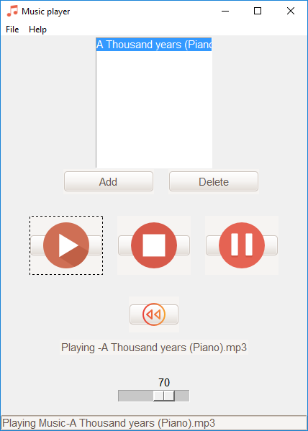

5.Song deleted from the playlist